**NOTICE OF LAND USE DECISION**

**You may have received this because you are an adjacent property owner, and this notice is required to be provided pursuant to ORS 215.416. The proposal is identified in this decision and will be located on the subject property.**

Coos County Planning

60 E. Second St.

Coquille, OR 97423

<http://www.co.coos.or.us/>

Phone: 541-396-7770

[planning@co.coos.or.us](mailto:planning@co.coos.or.us)

This decision notice is required to be sent to the property owner(s), applicant(s), adjacent property owners (distance of notice is determined by zone area – Urban 100 feet, Rural 250 feet, and Resource 750 feet), special taxing districts, agencies with interest, or person that has requested notice. Please read all information carefully as this decision. (See attached vicinity map for the location of the subject property).

Date of Notice: **Friday, April 15, 2022**

File No(s): D-22-001

Proposal: Request for a land use determination and approval for a Lawfully Created Unit of Land Application.

Landowner(s): HARLESS, BONNIE J.

PO BOX 158

BROADBENT, OR 97414-0158

Staff Planner: Crystal Orr, Planner I

Decision: **Approved with Conditions.** All decisions are based on the record. This decision is final and effective at close of the appeal period unless a complete application with the fee is submitted by the Planning Department at 5 p.m. on **Wednesday, April 27, 2022**. Pursuant to Section 5.8.100 Lawfully Created Unit of Land Applications and Property Line Adjustments are appealable within twelve (12) days the written notice is mailed. Appeals are based on the applicable land use criteria. Lawfully Created Unit of Land applications are subject to Coos County Zoning and Land Development Ordinance (CCZLDO) General Compliance with *Sections 1.1.300 Compliance with Comprehensive Plan and Ordinance Provisions, CCZLDO Article 6.1 Lawfully Created Lots and Parcels.* **Civil matters including property disputes outside of the criteria listed in this notice will not be considered. For more information please contact the staff planner listed in this notice.**

**Property Information**

|  |  |  |  |  |  |  |  |  |  |  |  |  |  |  |  |  |  |  |  |  |  |  |  |  |  |  |
| --- | --- | --- | --- | --- | --- | --- | --- | --- | --- | --- | --- | --- | --- | --- | --- | --- | --- | --- | --- | --- | --- | --- | --- | --- | --- | --- |
| |  |  |  |  |  | | --- | --- | --- | --- | --- | | File Numbers | Map Number(s) | Account  Number | Zoning | Total Property  Acreage | | D-22-001 | 28S130700-00100 | 901700 | EFU/F | 36.32 | | Lawfully Created Unit of | 28S130700-00200 | 901600 | EFU/F | 24.32 | | Land Determination | 28S130800-00400 | 902800 | EFU/CREMP | 40 | |  |  |  |  |  | |  |

The purpose of this notice is to inform you about the proposal and decision, where you may receive more information, and the requirements if you wish to appeal the decision by the Director to the Coos County Hearings Body. Any person who is adversely affected or aggrieved or who is entitled to written notice may appeal the decision by filing a written appeal in the manner and within the time period as provided below pursuant to Coos County Zoning and Land Development Ordinance (CCZLDO) Article 5.8. If you are mailing any documents to the Coos County Planning Department the address is 250 N. Baxter, Coquille OR 97423. Mailing of this notice to you precludes an appeal directly to the Land Use Board of Appeals.

Mailed notices to owners of real property required by ORS 215 shall be deemed given to those owners named in an affidavit of mailing executed by the person designated by the governing body of a county to mail the notices. The failure of the governing body of a county to cause a notice to be mailed to an owner of a lot or parcel of property created or that has changed ownership since the last complete tax assessment roll was prepared shall not invalidate an ordinance. NOTICE TO MORTGAGEE, LIENHOLDER, VENDOR OR SELLER: ORS CHAPTER 215 (ORS 215.513) REQUIRES THAT IF YOU RECEIVE THIS NOTICE, IT MUST PROMPTLY BE FORWARDED TO THE PURCHASER.

The application, staff report and any conditions may be found at the following link: <https://www.co.coos.or.us/planning/page/applications-2022> The application and all documents and evidence contained in the record, including the staff report and the applicable criteria, are available for inspection, at no cost, in the Planning Department located at 60 E. Second St., Coquille, Oregon; however, an appointment is required to be setup for viewing purposes. Copies may be purchased at a cost of 50 cents per page. The decision is based on the application submittal and information on record. The name of the Coos County Planning Department representative to contact is Crystal Orr, Planner I and the telephone number where more information can be obtained is **(541) 396-7770**.

Failure of an issue to be raised in a hearing, in person or in writing, or failure to provide statements of evidence sufficient to afford the Approval Authority an opportunity to respond to the issue precludes raising the issue in an appeal to the Land Use Board of Appeals.

**Reviewed by: Date: Friday, April 15, 2022** .

Crystal Orr, Planner I

**This decision is authorized by the Coos County Planning Director, Jill Rolfe based on the staff’s analysis of the Findings of Fact, Conclusions, Conditions of approval, Application and all evidence associated as listed in the exhibits.**

EXHIBITS

Exhibit A: Conditions of Approval

Exhibit B: Vicinity Map

Exhibit C: Lawfully Created Unit Map and Deeds

The following exhibits are on file at the Coos County Planning Department and may be accessed by contacting the department. All noticeable decisions are posted on the website for viewing when possible.

Exhibit D: D-22-001 Staff Report -Findings of Fact and Conclusions

**EXHIBIT “A”**

**CONDITIONS OF APPROVAL**

The applicant (applicant includes property owner and any successor) shall comply with the following conditions of approval with the understanding that all costs associated with complying with the conditions are the responsibility of the applicants and that the applicants are not acting as an agent of the county. If the applicant fails to comply or maintain compliance with the conditions of approval the permit may be revoked as allowed by the Coos County Zoning and Land Development Ordinance. Please read the following conditions of approval and if you have any questions contact planning staff. This is a tentative decision and will become final if the conditions of approval are completed correctly and any required survey maps and/or deeds are completed.

1. Once the appeal period has expired and no appeal have been filed, the applicant shall record the deed descriptions for the units of land and record them prior to any reconfiguration such as a property line adjustment. A copy of that deed needs to be provided to the Planning Department showing the process has been completed.
2. These properties shall be placed on separate deeds within ninety days of the date of the final decision which is calculated in Section 5.0.250. Once lawful parcels or lots have been established pursuant to LDO Section 6.1.125 those lots or parcels shall remain lawfully created or discrete lots or parcels unless the lot or parcel lines are vacated or the lot or parcel is further divided, as provided by law. If a parcel or lot is reconfigured by a property line adjustment that becomes the new discrete lot or parcel and the official date of creation.
3. Easements will need to be provide for each lawfully created unit of land that does not directly access a public right-of-way, and at the time of development (if developed) the property owner will be required to bring any roads or driveways to current design standards to support the proposed development.

**EXHIBIT “B”**

**Vicinity Map**

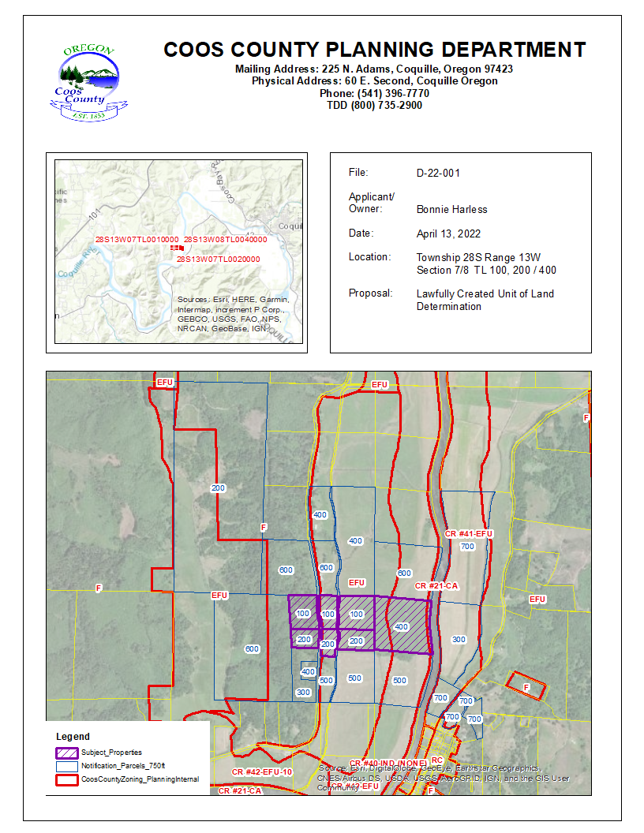

**EXHIBIT “C”**

**Lawfully Created Parcel Maps & Deeds**

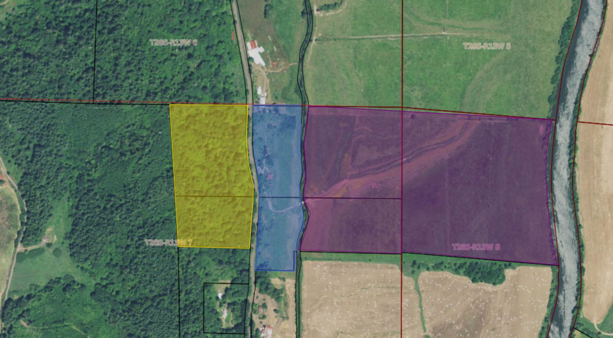

|  |
| --- |
| **EXHIBIT “D”**  **Staff Report** |
| **Findings of Fact and Conclusions** |

## PROPOSAL AND BACKGROUND/PROPERTY HISTORY INFORMATION:

1. **Proposal:** The proposal is a request for Planning Director Approval of Lawfully Created Units of Land. This application contains three (3) lawfully discrete units of land.
2. **LOCATION:**

These units of land are located southwest of the City of Coquille. The properties are accessed via North Bank Lane. Coquille River abuts the properties to the east. Iowa Slough runs through the parcels.

1. **ZONING:**

There is Exclusive Farm Use (EFU), Forest (F), and Coos Bay Estuary Management Plan (CMEMP) zoning on the subject properties.

ARTICLE 4.2 – ZONING PURPOSE AND INTENT

Section 4.2.500 Resource Zones

Forest (F) - The intent of the Forest District is to include all inventoried "forestlands" not otherwise found to be needed (excepted) for other uses. The purpose of the Forest zone is to conserve and protect forest land for forest uses. Some of the areas covered by the “F” zone are exclusive forest lands, while other areas include a combination of mixed farm and forest uses.

**Forest Mixed Use (FMU)**

The purpose of the Forest Mixed Farm-Forest Areas (“MU” areas) is to include land which is currently or potentially in farm-forest use. Typically such lands are those with soil, aspect, topographic features and present ground cover that are best suited to a combination of forest and grazing uses. The areas generally occupy land on the periphery of large corporate and agency holdings and tend to form a buffer between more remote uplands and populated valleys. In addition, these “mixed use” areas contain ownership of smaller size than in prime forest areas. Some are generally marginal in terms of forest productivity, such as areas close to the ocean.

If land is in a zone that allows both farm and forest uses, a dwelling may be sited based on the predominate use of the tract on January 1, 1993. If a use is only allowed in the mixed use zone it will be explained in the text. Otherwise the uses listed are allowed in both the Forest and Forest Mixed Use zones.

**Exclusive Farm Use (EFU)**

These include all inventoried "agricultural lands" not otherwise found to be needed (excepted) for other uses.

The purpose of the EFU district is to preserve the integrity and encourage the conservation of agricultural lands within Coos County and thereby comply with the provisions of ORS 215 and OAR 660. Division 33 to minimize conflicts between agricultural practices and non-farm uses by limiting any development to uses distinguished as dependent upon or accessory to supporting agricultural or forestry production and which qualify such farm lands for special tax relief pursuant to the provisions of Oregon Revised Statutes. This zone is also for the cultivation and marketing of specialty crops, horticultural crops and other intensive farm uses.

**Coquille River Estuary Management Plan - Exclusive Farm Use (CREMP-EFU) Shoreland Segments**

Exclusive Farm Use Shoreland Segments: 27 (27-EFUS), 28 (28-EFUS), 31(31-EFUS), 32(32-EFUS), 33 (33-EFUS), 34 (34-EFUS), 36 (36-EFUS), 37 (37-EFUS), 41 (41-EFUS), 42 (42-EFUS), 43 (43-EFUS), 44 (44-EFUS), 47(47-EFUS), 53(53-EFUS), 55 (55-EFUS), 56 (56-EFUS), 60 (60-EFUS), 62 (62-EFUS), 73 (73-EFUS), 75 (75-EFUS) shall be managed for the continuation of farm use as defined in ORS 215.203 (2)(a) and such other farm uses as are conditionally permitted in ORS 215.213.

**Coquille River Estuary Management Plan - Conservation Aquatic Units (CREMP-CA)**

Conservation Aquatic Unit 21 (21-CA) shall be managed to conserve and enhance to aquatic resources of the main river channel and fringing intertidal areas, while allowing such minor alterations as are necessary for the continuation of recreational boating and other shallow draft navigation. Removal of snags, old pilings and other obstructions from the river, and bank stabilization shall also be encouraged.

1. **SITE DESCRIPTION AND SURROUNDING USES:**

Based on aerial imagery, the subject properties in this area are used for farm and forest uses. There is residential development alongside North Bank Lane.

1. **LOCATION:**

These units of land are located southwest of the City of Coquille. Coquille River abuts the properties to the east. The properties are bisected by and accessed via North Bank Lane. The map below shows a general location of the properties.

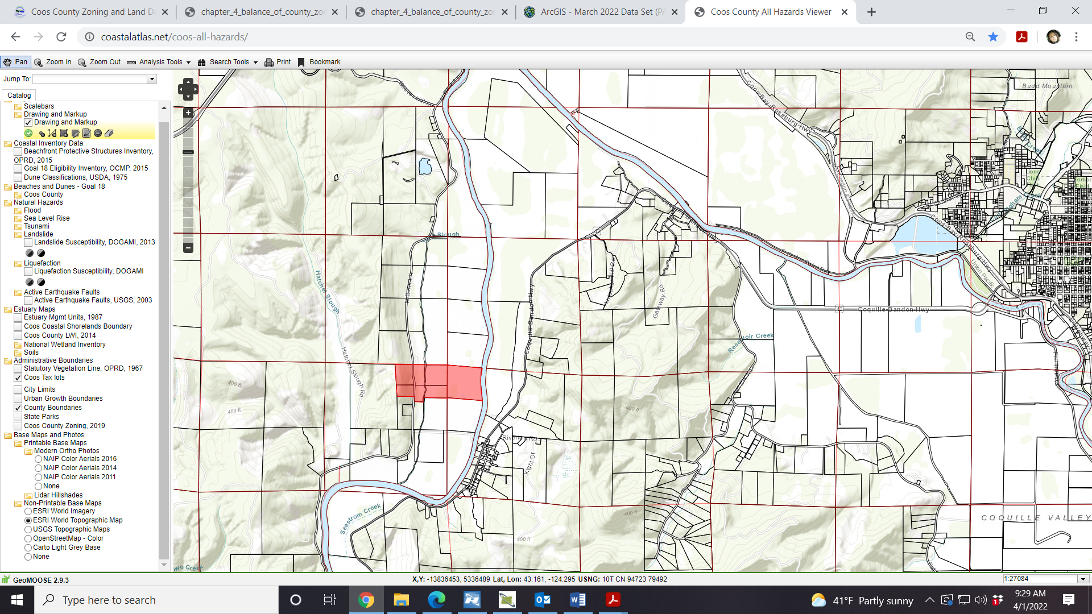

1. **Property Compliance:**
2. ***COMPLIANCE PURSUANT TO SECTION 1.1.300****:  It shall be unlawful for any person, firm, or corporation to cause, develop, permit, erect, construct, alter or use any building, structure or parcel of land contrary to the provisions of the district in which it is located.  No permit for construction or alteration of any structure shall be issued unless the plans, specifications, and intended use of any structure or land conform in all respects with the provisions of this Ordinance.*

**FINDING: Staff has reviewed the property history and the county finds to determine at the time of this report that this property is compliant. This does not mean that there is not additional information that was unavailable during this review that would make the properties non-compliant.**

1. **staff findings and conclusions:**

## *summary of proposal and applicable review criteria:*

The proposal is for Planning Director Approval of a Lawfully Created Unit of Land is subject to Coos County Zoning and Land Development (CCZLDO) Article 6.1.

1. ***COMMENTS:***

Comments were requested from the Coos County Assessor’s and Surveyor’s Office but not were received.

1. **LAWFULLY CREATED:** 
   * **ARTICLE 6.1 LAWFULLY CREATED LOTS AND PARCELS:**

*A legal lot is a lot or parcel created in compliance with the current state and county regulations for land divisions. Lots are created through subdivisions (4 or more lots is a subdivision) and parcels are created through a partition (3 or less parcels is a partition). Additionally, this ordinance recognizes that parcels may be created through other means that were consistent with a prior county ordinance or state law such as the adoption of different land division provisions [December 6, 1962 - December 31, 1985 ordinances in place prior to acknowledgement of the Coos County Comprehensive Plan (CCCP)]. Parcels created prior to the adoption of the current acknowledged CCCP (1986) may require an application to determine the legality of said parcel.*

*Once lawful parcels or lots have been established pursuant to LDO Section 6.1.125 those lots or parcels shall remain lawfully created or discrete lots or parcels unless the lot or parcel lines are vacated, or the lot or parcel is further divided, as provided by law. If a parcel or lot is reconfigured by a property line adjustment that becomes the new discrete lot or parcel and the official date of creation.*

* + ***SECTION 6.1.100 WHAT IS NOT A LAWFULLY CREATED LOT OR PARCEL:***

*A unit of land shall not be considered a separate parcel simply because the subject tract of land;*

1. *Is a unit of land created solely to establish a separate tax account;*
2. *Includes properties that have divided interest;*
3. *Lies in different counties;*
4. *Lies in different sections or government lots;*
5. *Lies in different land use or zoning designations; or*
6. *Is dissected by a public or private road.*
   * ***SECTION 6.1.125 LAWFULLY CREATED Unit of land***

*“Lawfully established unit of land” means:*

1. *The unit of land was created:*
   1. *Through an approved or pre-ordinance plat;*
   2. *Through a prior land use decision including a final decision from a higher court. A higher court includes the Land Use Board of Appeals;*
   3. *In compliance with all applicable planning, zoning and subdivision or partition ordinances and regulations at the time it was created.*
   4. *By a public dedicated road that was held in fee simple creating an interviewing ownership prior to January 1, 1986;*
   5. *By deed or land sales contract, if there were no applicable planning, zoning or subdivision or partition ordinances or regulations that prohibited the creation.*
   6. *By the claim of intervening state or federal ownership of navigable streams, meandered lakes or tidewaters. “Navigable-for-title” or “title-navigable” means that ownership of the waterway, including its bed, was passed from the federal government to the state at statehood. If a waterway is navigable-for-title, then it also is generally open to public use for navigation, commerce, recreation, and fisheries.*

*2. Creation of parcel previously approved but not acted upon (92.178).*

*a. The governing body of a county may approve an application requesting formation of one parcel if the county issued a land use decision approving the parcel prior to January 1, 1994, and:*

*b. A plat implementing the previous land use decision was not recorded; or*

*c. A condition of approval of the previously approved land use decision requiring consolidation of adjacent lots or parcels was not satisfied by a previous owner of the land.*

*d. An application under this section is not subject to ORS 215.780.*

*e. Approval of an application under this section does not affect the legal status of land that is not the subject of the application.*

* + ***SECTION 6.1.150 APPLICATIONS ESTABLISHING LAWFULLY CREATED LOTS OR PARCELS:***

*An application to establish a lawfully created unit of land shall be submitted in the case of Section 6.1.125.1.d, e and f and Section 6.1.125.2. This is an administrative land use decision. If County Counsel is required to review information to determine legal status of the unit of land additional fees may be charged.*

*All notices will be provided in accordance with LDO Section 5.0.*

*Once it is determined that a lawfully created unit of land exists it shall be separated out on its own deed prior to any reconfiguration such as a property line adjustment. A copy of that deed needs to be provided to the Planning Department showing the process has been completed. If there are more than two lawfully created units of land (discrete parcels) found to exist a road may be required to provide access. The applicable road standards in Chapter VII will apply.*

**Finding: The Lawfully Created Unit of Land application was received on March 28, 2022. The application was not deemed complete as this notice of decision is being sent out prior to the applicable 30 day deemed complete review time.   
  
Bonnie Harless submitted information to certify that there are lawfully created units of land within tax lots 100 & 200 in Township 28, Range 13, Section 07 and tac lot 400 in Township 28, Range 13, Section 08. These parcels are all described on the same deed, Book 283 page 341.**

**Iowa Slough created a lawfully created unit of land (the purple portion below in the map) pursuant to 6.1.125.1.f “*By the claim of intervening state or federal ownership of navigable streams, meandered lakes or tidewaters. “Navigable-for-title” or “title-navigable” means that ownership of the waterway, including its bed, was passed from the federal government to the state at statehood. If a waterway is navigable-for-title, then it also is generally open to public use for navigation, commerce, recreation, and fisheries.”* The blue and yellow portions of the parcel are lawfully created discrete parcels as North Bank Lane created an intervening ownership, pursuant to 6.1.125.d *By a public dedicated road that was held in fee simple creating an interviewing ownership prior to January 1, 1986.***



**Therefore, after reviewing all of the evidence Planning Staff can acknowledge that the units of land identified within the above map are lawfully created units of land.**

1. **DECISION:**

The proposal meets the requirements of the Coos County Zoning and Land Development Ordinance, with conditions listed in Exhibit “A” of this report.

1. **Expiration:**

Once lawful parcels or lots have been established pursuant to LDO Section 6.1.125 those lots or parcels shall remain lawfully created or discrete lots or parcels unless the lot or parcel lines are vacated, or the lot or parcel is further divided, as provided by law. If a parcel or lot is reconfigured by a property line adjustment that becomes the new discrete lot or parcel and the official date of creation. Therefore, there is not expiration for this type of application.

1. **Notice requirements:**

A notice of decision will be provided to property owners within 750 feet of the subject properties and the following agencies, special district or parties: There are no special districts.

A Notice of Decision and Staff Report will be provided to the following: Applicants/Owners; Coos County Surveyor, Coos County Assessor’s Office, Oregon Department of Land Conservation and Development; Coos County Planning Commission; and the Board of Commissioners.

Adjacent property owners will receive a Notice of Decision and maps, but all other attachments can be found by contacting the Planning Department or visiting the website. If not found on the website the public may contact the department to view the official record.

**EXHIBIT “E”**

**APPLICATIONS RECEIVED**