DATE : June 16, 2021

TO : Technical Review Committee Members

Troy Rambo

PO Box 809

North Bend, OR 97459

Terry & Connie Emerson

94037 Van Elsberg Lane

Coos Bay, OR 97420

FROM : Crystal Orr, Planning Specialist

SUBJECT : Review of Tentative Land Division for File No. P-21-002

Township 26S, Range 13W, Section 24A Tax Lot 500

MEETING DATE: TRC P-21-002   
  
Thu, Jun 24, 2021 9:00 AM - 9:30 AM (PDT)   
  
**Please join my meeting from your computer, tablet or smartphone.**   
<https://global.gotomeeting.com/join/162029837>   
  
**You can also dial in using your phone.**   
United States: [+1 (872) 240-3212](tel:+18722403212,,162029837)   
  
**Access Code:** 162-029-837   
  
  
New to GoToMeeting? Get the app now and be ready when your first meeting starts: <https://global.gotomeeting.com/install/162029837>

Proposal: The proposal is for a three (3) parcel land division.

Road Status: Van Elsberg Lane, which is a private, privately maintained road. Gypsy Drive is off of Ross Inlet Road, which is a public Coos County-maintained street.

LAWFULLY This parcel was lawfully created through deed document 73-85645

CREATED

CURRENT According to the Tentative Partition Map there is a Single Family Dwelling,

DEVELOPMENT: Garage and AG Buildingon the property.

Copies of the application and maps have been provided to all committee members. The land division Technical Review Committee (TRC) is established to act in a technical review capacity for the Board of Commissioners, and is authorized to perform such functions as provided for in this Ordinance. The TRC shall meet within 30 days of the application being deemed complete. The TRC shall consist of the following members **or their duly authorized representatives**:

1. Director or Planning Staff Member, who shall serve as Chair;
2. Director – County Public Works (i.e., Roadmaster)
3. County Surveyor;
4. County Assessor;
5. County Counsel;
6. Health Department Staff (water and sanitation issues);
7. County Planning Commission Chairman;
8. Department of Environmental Quality (DEQ);
9. Oregon Department of Transportation (if access is proposed from a state facility)
10. Representative of Affected City (if located in an urban growth area); and
11. Representative of Affected Special District.
12. Effected Utility Companies
13. Special Assessment

Responsibility of TRC is to examine all tentative (preliminary) partition plats, subdivision plats, and planned unit development plats, and assist the Planning Director in rendering a decision relating to the approval, conditional approval, or disapproval of said applications. In case of a variance request, the TRC shall form a committee recommendation to the Planning Director. The applicant shall be given notice of any TRC meeting pertaining to his or her request. In the event a committee member is unable to attend the meeting written comments should be made prior the meeting.

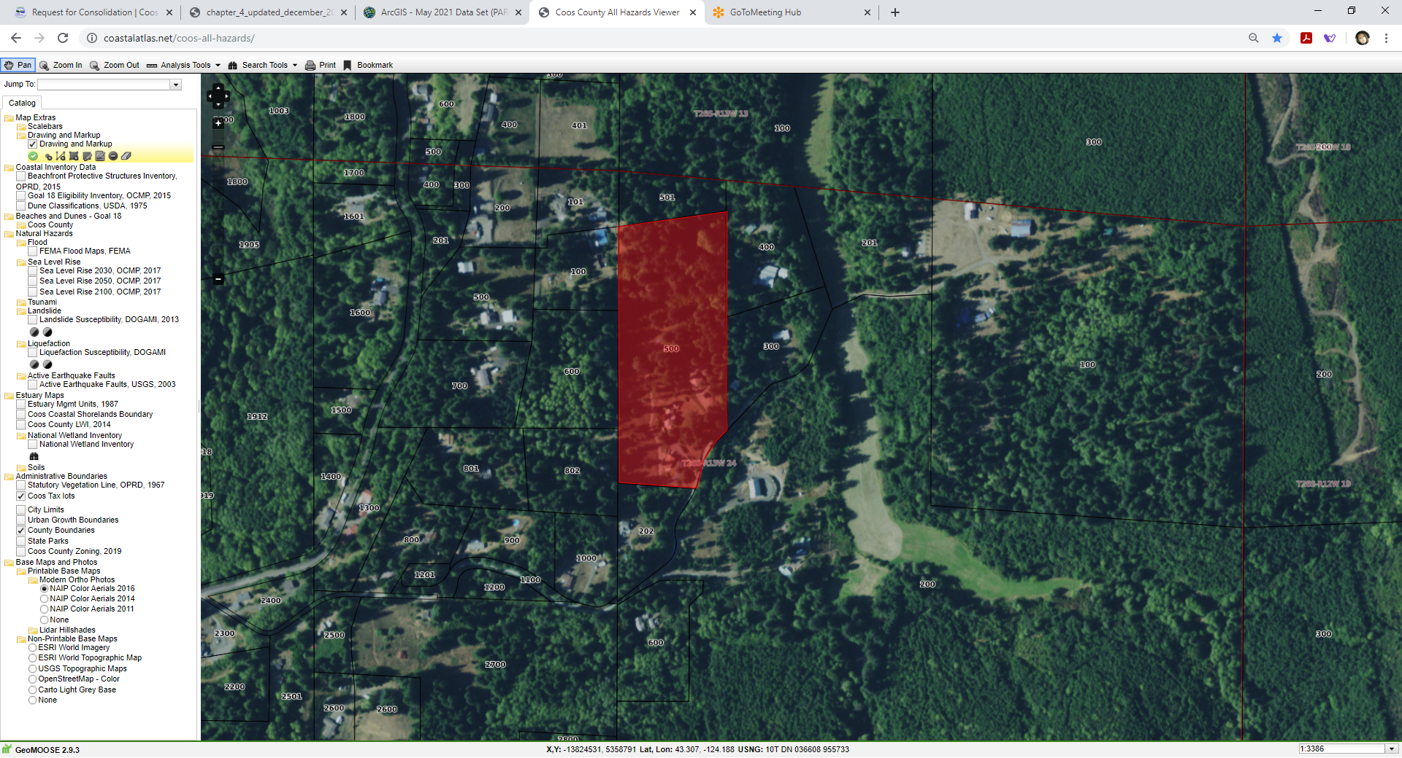

Subject Property

**Property Details:**

534504

26S1324A0-00500

EMERSON, TERRY L. & CONNIE L.

94037 VAN ELSBERG LN

COOS BAY, OR 97420-6376

94037 VAN ELSBERG LN COOS BAY, OR 97420

12.08 Acres

RURAL RESIDENTIAL-2 (RR-2)

