NOTICE OF LAND USE DECISION

Coos County Planning
225 N. Adams St.
Coquille, OR 97423
http://www.co.coos.or.us/
Phone: 541-396-7770
Fax: 541-396-1022

This decision notice is required to be sent to the property owner(s), applicant(s), adjacent property owners (distance of notice is determined by zone area – Urban 100 feet, Rural 250 feet, and Resource 750 feet), special taxing districts, agencies with interest, or person that has requested notice. The development is contained within the identified property owners land. Notice is required to be provided pursuant to ORS 215.416. Please read all information carefully as this decision. (See attached vicinity map for the location of the subject property).

NOTICE TO MORTGAGEE, LIENHOLDER, VENDOR OR SELLER: ORS CHAPTER 215 (ORS 215.513) REQUIRES THAT IF YOU RECEIVE THIS NOTICE, IT MUST PROMPTLY BE FORWARDED TO THE PURCHASER.

Date of Notice: Thursday, June 24, 2021

File No: PLA-21-026

Proposal: Request for a land use authorization for a Property Line Adjustment
Applicant(s): Brett Clarno

66528 Schoolhouse Rd
North Bend, OR 97459

Surveyor: Walter White, SHN Engineering

Staff Planner: Crystal Orr, Planner I
Decision: Approved with Conditions. All decisions are based on the record. This decision is final and effective at close of the appeal period unless a complete application with the fee is submitted by the Planning Department at 5 p.m. on Tuesday, July 06, 2021 . Appeals are based on the applicable land use criteria. Civil matters including property disputes outside of the criteria listed in this notice will not be considered. Property line adjustments are subject to Coos County Zoning and Land Development Ordinance (CCZLDO) Article 6.3 Property Line Adjustments. Civil matters including property disputes outside of the criteria listed in this notice will not be considered. For more information please contact the staff planner listed in this notice.

Property Information
Account Numbers  Map Numbers  Property Owners  Situs Addresses  Acreages  Zonings | 255800/99920209  25S120500-01100/ 25S120500-01105  CLARNO, BRETT & GEORGIANNA  66528 SCHOOLHOUSE RD  NORTH BEND, OR 97459  66319 NELSON LN NORTH BEND, OR 97459  5.84 Acres/ 42.04 Acres  EXCLUSIVE FARM USE (EFU) | 99919688  25S1206D0-00409  CLARNO, BRETT  66528 SCHOOLHOUSE RD  NORTH BEND, OR 97459-7564  94913 KENTUCK WAY NORTH BEND, OR 97459  13.93 Acres  EXCLUSIVE FARM USE (EFU)
The purpose of this notice is to inform you about the proposal and decision, where you may receive more information, and the requirements if you wish to appeal the decision by the Director to the Coos County Hearings Body. Any person who is adversely affected or aggrieved or who is entitled to written notice may appeal the decision by filing a written appeal in the manner and within the time period as provided below pursuant to Coos County Zoning and Land Development Ordinance (CCZLDO) Article 5.8. If you are mailing any documents to the Coos County Planning Department the address is 250 N. Baxter, Coquille OR 97423. Mailing of this notice to you precludes an appeal directly to the Land Use Board of Appeals.

Mailed notices to owners of real property required by ORS 215 shall be deemed given to those owners named in an affidavit of mailing executed by the person designated by the governing body of a county to mail the notices. The failure of the governing body of a county to cause a notice to be mailed to an owner of a lot or parcel of property created or that has changed ownership since the last complete tax assessment roll was prepared shall not invalidate an ordinance.

The application, staff report and any conditions can be found at the following link: https://www.co.coos.or.us/planning/page/applications-2021-2application and all documents and evidence contained in the record, including the staff report and the applicable criteria, are available for inspection, at no cost, in the Planning Department located at 225 North Adams Street, Coquille, Oregon. Copies may be purchased at a cost of 50 cents per page. The decision is based on the application submittal and information on record. The name of the Coos County Planning Department representative to contact is Crystal Orr, Planner I and the telephone number where more information can be obtained is (541) 396-7770.

Failure of an issue to be raised in a hearing, in person or in writing, or failure to provide statements of evidence sufficient to afford the Approval Authority an opportunity to respond to the issue precludes raising the issue in an appeal to the Land Use Board of Appeals.

Reviewed by: Date: Thursday, June 24, 2021 .
Crystal Orr, Planner I

This decision is authorized by the Coos County Planning Director, Jill Rolfe based on the staff’s analysis of the Findings of Fact, Conclusions, Conditions of approval, Application and all evidence associated as listed in the exhibits.

EXHIBITS
Exhibit A: Conditions of Approval
Exhibit B: Vicinity Map
Exhibit C: Before & After Maps

The Exhibits below are mailed to the Applicant. Emailed copies of the exhibits are provide to the Board of Commissioners, Planning Commission and Department of Land Conservation and Development. Copies are available upon request or at the following by contacting the Planning Department or by visiting the website:http://www.co.coos.or.us/Departments/Planning/PlanningDepartment-Applications2020.aspx ; however if not found on the webpage please contact staff for further instructions on viewing the official record in this matter. If you have any questions please contact staff at (541) 396-7770.

Exhibit D: PLA-21-026 Staff Report -Findings of Fact and Conclusions
Exhibit E: Comments Received
Exhibit D: Application

EXHIBIT “A”
CONDITIONS OF APPROVAL
The applicant shall comply with the following conditions of approval with the understanding that all costs associated with complying with the conditions are the responsibility of the applicants and that the applicants are not acting as an agent of the county. If the applicant fails to comply or maintain compliance with the conditions of approval the permit may be revoked as allowed by the Coos County Zoning and Land Development Ordinance. Please read the following conditions of approval and if you have any questions contact planning staff.
- All applicable mapping and filing requirements shall be complied with as listed below. If a map is required it shall be submitted to the Surveyor’s office with the deeds. The deeds shall not be filed and that map has the appropriate signatures. Copies of all recorded deeds shall be submitted as the final step in the process.
- Shall comply with any requirements from Coos County Surveyor or Assessor’s Office.
Mapping and Filing Requirements
- Map and Monuments Required:
  - For any resulting lot or parcel ten acres or less, a survey map that complies with ORS 209.250 shall be prepared;
  - The survey map shall show all structures within ten (10) feet of the adjusted line;
  - The survey shall establish monuments to mark the adjusted line.
- Approval and Filing Requirements:
  - Upon determination that the requirements of this section have been met, the Director shall advise the applicant in writing that the line adjustment is tentatively approved;
  - Within one year from the date of tentative approval, the applicant shall prepare and submit to the Director any map required by Section 6.2.800(4) and Section 6.2.800(5) if a survey is required. If no map is required, the applicant shall submit proof that the requirements of the tentative approval have been met. The Director shall indicate final approval by endorsement upon the map, if any, or if no map is required the Director shall advise the applicant in writing that final approval has been granted;
c. Once endorsed by the Director, the map shall then be submitted to the County Surveyor. When the map is filed, the County Surveyor shall indicate the filing information on the map;
d. A line adjustment shall be effective when the map is filed by the County Surveyor and an instrument (e.g. deed or covenant) is recorded with the County Clerk. If no map is required, then the line adjustment shall be effective when final approval is granted by the Director and an instrument is recorded with the County Clerk;
e. If a survey is required, the Deed shall be recorded and the Survey Map shall be filed simultaneously. The survey map, with the signature of the Coos County Planning Director shall be submitted to the County Surveyor along with the required filing fee. The survey map will be given a filing number which will be added to the Property Line Adjustment deed. The deed will then be recorded whereupon the recording number for said deed will be added to the face of the survey map. Said map will then be filed with the County Surveyor, completing the process.
- The property line adjustment deed must be submitted on the exact format found in § 6.3.175.f.
EXHIBIT “B”
VICINITY MAP

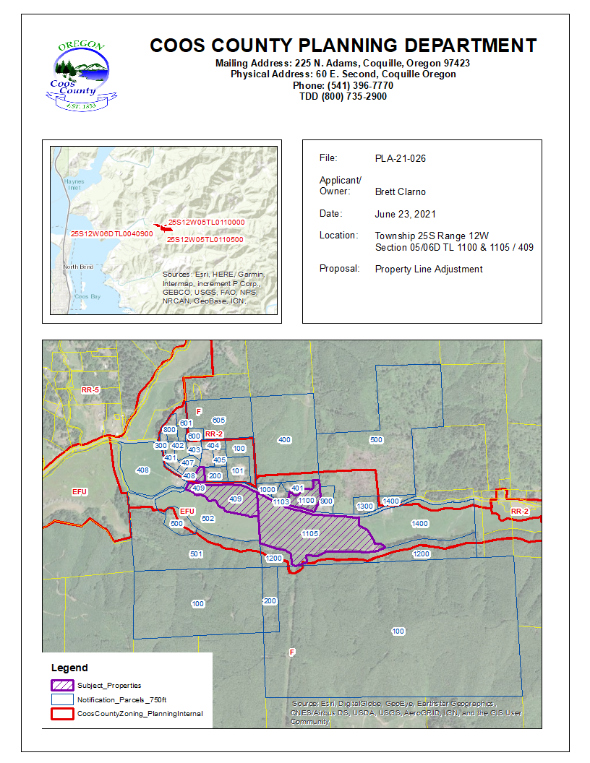

EXHIBIT “C”
BEFORE & AFTER MAPS
Before
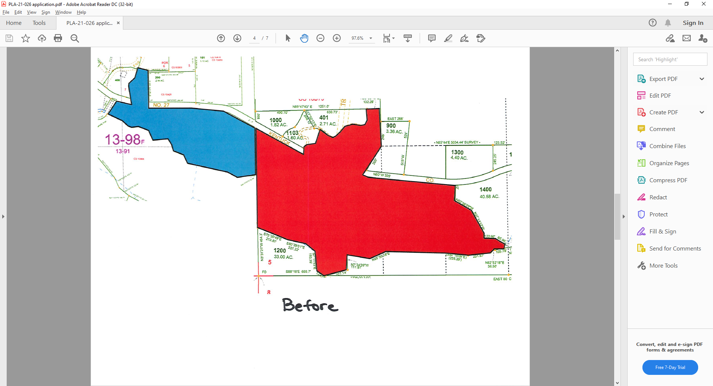

After
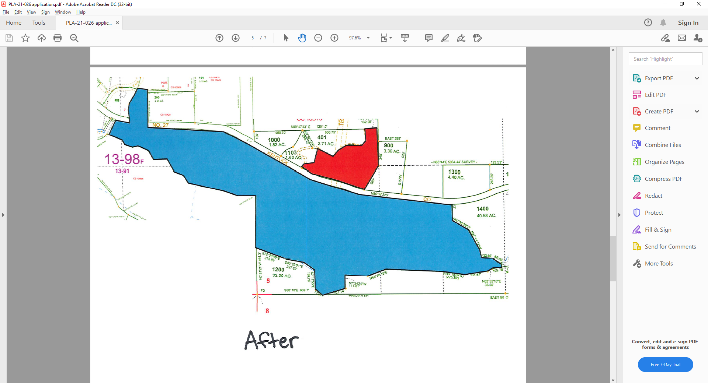

Exhibit “C”
Staff Report
Findings of Fact and Conclusions

- Proposal and background/pROPERTY HISTORY information:

- PROPOSAL: To reconfigure the lots to correct a violation that was caused when the lots were adjusted. The proposed lots are already adjusted into the desired configuration, this is an after the fact application to approve that configuration.

- BACKGROUND/PROPERTY HISTORY:
The properties background history has been reviewed and other than the correct an improperly recorded property line adjustment there appear to be no violations found.

- BASIC FINDINGS:
  - LOCATION: The subject properties are located off of Kentuck Way Lane, northeast of the City of North Bend.

  - ZONING: - The subject properties are zoned Exclusive Farm Use and Rural Residential (tax lot 409 is split zoned).

ARTICLE 4.2 – ZONING PURPOSE AND INTENT
SECTION 4.2.500 RESOURCE ZONES
Forest (F): The intent of the Forest District is to include all inventoried "forestlands" not otherwise found to be needed (excepted) for other uses.

The purpose of the Forest zone is to conserve and protect forest land for forest uses. Some of the areas covered by the “F” zone are exclusive forest lands, while other areas include a combination of mixed farm and forest uses.

Forest Mixed Use (FMU): The purpose of the Forest Mixed Farm-Forest Areas (“MU” areas) is to include land which is currently or potentially in farm-forest use. Typically, such lands are those with soil, aspect, topographic features and present ground cover that are best suited to a combination of forest and grazing uses. The areas generally occupy land on the periphery of large corporate and agency holdings and tend to form a buffer between more remote uplands and populated valleys. In addition, these “mixed use” areas contain ownership of smaller size than in prime forest areas. Some are generally marginal in terms of forest productivity, such as areas close to the ocean.

If land is in a zone that allows both farm and forest uses, a dwelling may be sited based on the predominate use of the tract on January 1, 1993.

If a use is only allowed in the mixed-use zone it will be explained in the text. Otherwise the uses listed are allowed in both the Forest and Forest Mixed Use zones.

  - SPECIAL DEVELOPMENT CONSIDERATIONS AND OVERLAYS:
SECTION 4.11.125 Special Development Considerations: The considerations are map overlays that show areas of concern such as hazards or protected sites. Each development consideration may further restrict a use. Development considerations play a very important role in determining where development should be allowed In the Balance of County zoning. The adopted plan maps and overlay maps have to be examined in order to determine how the inventory applies to the specific site

SECTION 4.11.200 Purpose: Overlay zones may be super-imposed over the primary zoning district and will either add further requirements or replace certain requirements of the underlying zoning district. The requirements of an overlay zone are fully described in the text of the overlay zone designations. An overlay zone is applicable to all Balance of County Zoning Districts and any zoning districts located within the Coos Bay Estuary Management Plans when the Estuary Policies directly reference this section.

No development is part of this proposal; therefore, no Special Development Considerations or Overlays are required to be addressed.

  - SITE DESCRIPTION AND SURROUNDING USES:

The subject properties are zoned Exclusive Farm Use (EFU) and Rural Residential-2 (RR-2).

  - COMMENTS:
  - PUBLIC AGENCY: Comments were requested from both the County Assessor’s Office and County Surveyor’s Office. Any comments received must be adhered to.

  - PUBLIC COMMENTS: This application request did not require any request for comments prior to the release of the decision.

  - LOCAL TRIBE COMMENTS: This application request did not require any request for comments prior to the release of the decision.

  - LAWFULLY CREATED UNIT OF LAND: Tax lot 409 was lawfully created through SUB-17-001, the current configuration was created through PLA-19-033. Tax lots 1100 1105 were legally created through prior planning permits. However, a Property Line Adjustments was not filed or recorded correctly and the purpose of this approval is to correct the prior error.

- staff findings and conclusions:

summary of proposal and applicable review criteria:

The proposal is for Planning Director Approval of a single Property Line Adjustment. The proposal is subject to Coos County Zoning and Land Development (CCZLDO) Article 6.3 Property Line Adjustments.

- Key definitions:
ACTIVITY: Any action taken either in conjunction with a use or to make a use possible. Activities do not in and of themselves result in a specific use. Several activities such as dredging, piling and fill may be undertaken for a single use such as a port facility. Most activities may take place in conjunction with a variety of uses.

DEVELOP: To bring about growth or availability; to construct or alter a structure, to conduct a mining operation, to make a physical change in the use or appearance of land, to divide land into parcels, or to create or terminate rights to access.

DEVELOPMENT: The act, process or result of developing.

USE: The end to which a land or water area is ultimately employed. A use often involves the placement of structures or facilities for industry, commerce, habitation, or recreation.

ZONING DISTRICT: A zoning designation in this Ordinance text and delineated on the zoning maps, in which requirements for the use of land or buildings and development standards are prescribed.

- Criteria and standards for Property Line Adjustments

Section 6.3.125 procedure:
- An application for a line adjustment or elimination shall be filed by the owners of all lots or parcels affected. The application shall be accompanied by an appropriate fee and contain the following information:

  - Reason for the line adjustment;
  - Vicinity map locating the proposed line adjustment or elimination in relation to adjacent subdivisions, partitions, other units of land and roadways;
  - A plot plan showing the existing boundary lines of the lots or parcels affected by the line adjustment and the approximate location for the proposed adjustment line. The plot plan shall also show the approximate location of all structures within ten (10) feet of the proposed adjusted line;
  - A current property report (less than 6 months old) indicating any taxes, assessment or other liens against the property, easements, restrictive covenants and rights-of-way, and ownerships of the property of the proposed development. A title report is acceptable.
  - A notice of application and decision will be provided to any and all lien holders of record for the property that will be affected by the proposed adjustment. Applicants should consult with any and all such lien holders prior to submittal of an application.

FINDING: The property line adjustment was submitted to correct a violation that was caused when the property was adjusted by deed without approval from the Coos County Planning Department.

A complete application with a plot plan showing the before and after maps was supplied.

Neither parcel has a lienholder. Therefore, these criteria have been addressed.

- A line adjustment is permitted only where an additional unit of land is not created and where the lot or parcel reduced in size by the adjustment complies with the requirements of the applicable zone except that a line adjustment for the purpose of exchange or transfer of land between resource land owners shall be allowed so long as:

  - No parcel is reduced in size contrary to a condition under which it was formed;
  - The resulting parcel sizes do not change the existing land use pattern (e.g. two conforming parcels must remain conforming); and
  - Two non-conforming parcels may remain non-conforming; and, two parcels, one conforming and one non-conforming, may remain as such regardless of which parcel is non-conforming after the exchange or transfer)

FINDING: The parcels do not contain encumbrances that would prohibit the boundary line adjustments. Tax lot 409 is a legal non-conforming lot as it is split zoned Exclusive Farm Use (EFU) and Rural Residential-2 (RR-2). The parcel does not meet the minimum lot size for either of those zoning districts as RR-2 requires two (2) acres and EFU requires 80 acres to meet the minimum lot size. Tax lots 1100 and 1105 are a legal non-conforming unit of land as it is zoned EFU and does not contain 80 acres.

Therefore, this request complies with the criteria under this section.

- An encroachment of existing or planned structures will not be created within required setbacks as a result of the line adjustment.

FINDING: No encroachment of existing structures will be created by adjusting the property boundary line. Therefore, this criterion has been met. Any future structures will be required to comply with the setback requirements in the applicable zoning district.

- A line adjustment for a lot or parcel that contains a dwelling, not on a public sanitation system, and is less than an acre before the adjustment and further reduced as a result of the adjustment shall obtain documentation from Department of Environmental Quality (DEQ) that the sanitation system will still meet their requirements.

FINDING: Neither unit of land will be reduced less than one (1) acre. Therefore, this condition does not apply.

- In resource lands, a unit of land containing a dwelling, or approved for construction of a dwelling, cannot be adjusted with a vacant resource unit of land for the purpose of qualifying the vacant unit for a 160-acre dwelling.

  - A resource unit of land less than 160 acres and containing a (preexisting) dwelling, or approved for construction of a dwelling, cannot be adjusted with a vacant resource unit of land for the purpose of qualifying the vacant unit for a 160-acre dwelling;
  - A resource unit of land 160 acres or greater and containing a (preexisting) dwelling, or approved for construction of a dwelling, cannot be adjusted below 160 acres with a vacant resource unit of land for the purpose of qualifying the vacant unit for a 160-acre dwelling;
  - A resource unit of land 160 acres or greater and containing a dwelling approved as a 160-acre dwelling, or approved for construction of a 160-acre dwelling, cannot be reduced below 160 acres for the purpose of qualifying the vacant unit for a 160-acre dwelling.

FINDING: The purpose of the line adjustment is not to qualify a dwelling site. Both properties are developed. Therefore, this criterion is not applicable.

- Same Designation: A line adjustment shall only be permitted where the sale or transfer of ownership is made between abutting owners of like designated lands, residential lands, commercial lands, industrial lands, resource lands, and estuary zoned lands unless an existing structure encroaches over an existing property boundary or the boundary line adjustment is required to comply with requirements of the State Department of Environmental Quality for a subsurface sewage system.

FINDING: Tax lot 409 is split zoned and tax lot 1100/1105 is solely zoned Exclusive Farm Use (EFU). After the adjustment tax lot 409 will remain split zoned and tax lot 1100/1105 will remain solely EFU. Therefore, this criterion has been met.

Section 6.3.150 EASEMENTS AND ACCESS:

A line adjustment shall have no effect on existing easements or access. Access shall not be eliminated through a property line adjustment process. If an access is potentially affected, then an easement may be created for access to comply with this criterion.

FINDING: There will be no effect on existing easements. Therefore, this criterion has been met.

- DECISION:
The proposed Property Line Adjustment meets the requirements of the Coos County Zoning and Land Development Ordinance, with conditions listed in Exhibit “A” of this report.

- Expiration:
This is a tentative approval that is valid for up to one year. To finalize this decision the applicant shall comply with the approval and filing requirements found in the conditions of approval in Exhibit “A” of this report once the appeal period has expired and an appeal has not be filed.

- Notice requirements:
A notice of decision will be provided to property owners within 750 feet of the subject properties and the following agencies, special districts, or parties

A Notice of Decision and Staff Report will be provided to the following: Applicants/Owners, Department of Land Conservation and Development, County Assessor, County Surveyor, Planning Commission and Board of Commissioners and Applicant’s Surveyor.

Adjacent property owners will receive a Notice of Decision and maps but all other attachments can be found by contacting the Planning Department or visiting the website. Anyone may contact the department to view the official record.

Exhibit “D”
APPLICATION
