Date of Notice: December 18, 2019

Coos County Planning

225 N. Adams St.

Coquille, OR 97423

<http://www.co.coos.or.us/>

Phone: 541-396-7770

Fax: 541-396-1022

**NOTICE OF LAND USE DECISION BY THE**

**COOS COUNTY PLANNING DIRECTOR**

File No: ACU-19-050

RE: Request for an accessory structure

Applicant(s): Tim Banaszek, Southport Lumber

PO Box 298

Coos Bay OR 97423

Owner(s): Southport Lumber Co. LLC

@ Jason Smith

PO Box 298

Coos Bay OR 97423

This decision notice serves as public notice to all participants, adjacent property owners, special districts, agency with interests, or person with interests. If you are an adjacent property owner, this notice is being mailed to you because the applicant has applied for a use or activity on their property that requires that you receive notice pursuant to ORS 197.763. Please read all information carefully as this decision may affect you. (See attached vicinity map for the location of the subject property).

Mailed notices to owners of real property required by ORS 215 shall be deemed given to those owners named in an affidavit of mailing executed by the person designated by the governing body of a county to mail the notices. The failure of a person named in the affidavit to receive the notice shall not invalidate an ordinance. The failure of the governing body of a county to cause a notice to be mailed to an owner of a lot or parcel of property created or that has changed ownership since the last complete tax assessment roll was prepared shall not invalidate an ordinance.

**NOTICE TO MORTGAGEE, LIENHOLDER, VENDOR OR SELLER: ORS CHAPTER 215 (ORS 215.513) REQUIRES THAT IF YOU RECEIVE THIS NOTICE, IT MUST PROMPTLY BE FORWARDED TO THE PURCHASER.”**

**The requested proposal has been Approved Denied subject to the findings to the criteria found in Exhibit A. Approval is based on findings and facts represented in the staff report.**

**Subject Property Information**

|  |  |
| --- | --- |
| Account Number:  Map Number:  Property Owner:  Situs Address:  Acreage:  Zoning:  Special Considerations: | 311100  25S130700-00200  SOUTHPORT LUMBER CO., LLC  @ SMITH, JASON  PO BOX 298  COOS BAY, OR 97420-0031  90800 TRANSPACIFIC PKWY NORTH BEND, OR 97459  33.53 Acres  COOS BAY ESTUARY MNGMT PLAN (CBEMP)  DEVELOPMENT AQUATIC (03-DA)  NON WTR DEPEND DEVLMT SHORLNDS (03-NWD)  WATER DEPEND DEVLOPMT SHORLNDS (03-WD)  AIRPORT - NORTH BEND - HORIZONTAL SURFACE (NBHS)  AIRPORT - NORTH BEND - RUNWAY PROTECTION ZONE (NBRPZ)  FLOODPLAIN (FP)  NAT. HAZARDS WIND EROSION (HZW)  NATIONAL WETLAND INVENTORY SITE (NWI) |
| Proposal/Criteria: | Request for Planning Director Approval of an accessory structure and use pursuant to Section 3.1.450 Supplemental Provisions that apply to all zoning that listed in Article 3. |

The application, staff report and any conditions can be found at the following link: <http://www.co.coos.or.us/Departments/Planning/PlanningDepartmentApplications-2019.aspx>. The application and all documents and evidence contained in the record, including the staff report and the applicable criteria, are available for inspection, at no cost, in the Planning Department located at 225 North Adams Street, Coquille, Oregon. Copies may be purchased at a cost of 50 cents per page. The decision is based on the application submittal and information on record. The name of the Coos County Planning Department representative to contact Crystal Orr, Planning Specialist and the telephone number where more information can be obtained is **(541) 396-7770**.

This decision will become final at 5 P.M. on April 18, 2019 unless before this time a completed **APPLICATION FOR AN APPEAL OF A DECISION BY THE PLANNING DIRECTOR** form is submitted to and received by the Coos County Planning Department.

Failure of an issue to be raised in a hearing, in person or in writing, or failure to provide statements of evidence sufficient to afford the Approval Authority an opportunity to respond to the issue precludes raising the issue in an appeal to the Land Use Board of Appeals.

**Prepared by: ­­­­­­­­­­­**  **Date:**  April 3, 2019

Crystal Orr, Planning Specialist

**Authorized by:**  **Date:** April 3, 2019

Jill Rolfe, Planning Director

# EXHIBITS

Exhibit A: Site Map

Exhibit B: Staff Report

**The Exhibits below are mailed/emailed to the Applicant and Planning Commission only. Copies are available upon request or at the following website:** <http://www.co.coos.or.us/Departments/Planning/PlanningDepartmentApplications-2018.aspx> **or by visiting the Planning Department at 225 N. Baxter, Coquille OR 97423. If you have any questions please contact staff at (541) 396-7770.**

**EXHIBIT "A"**

**Site Map**

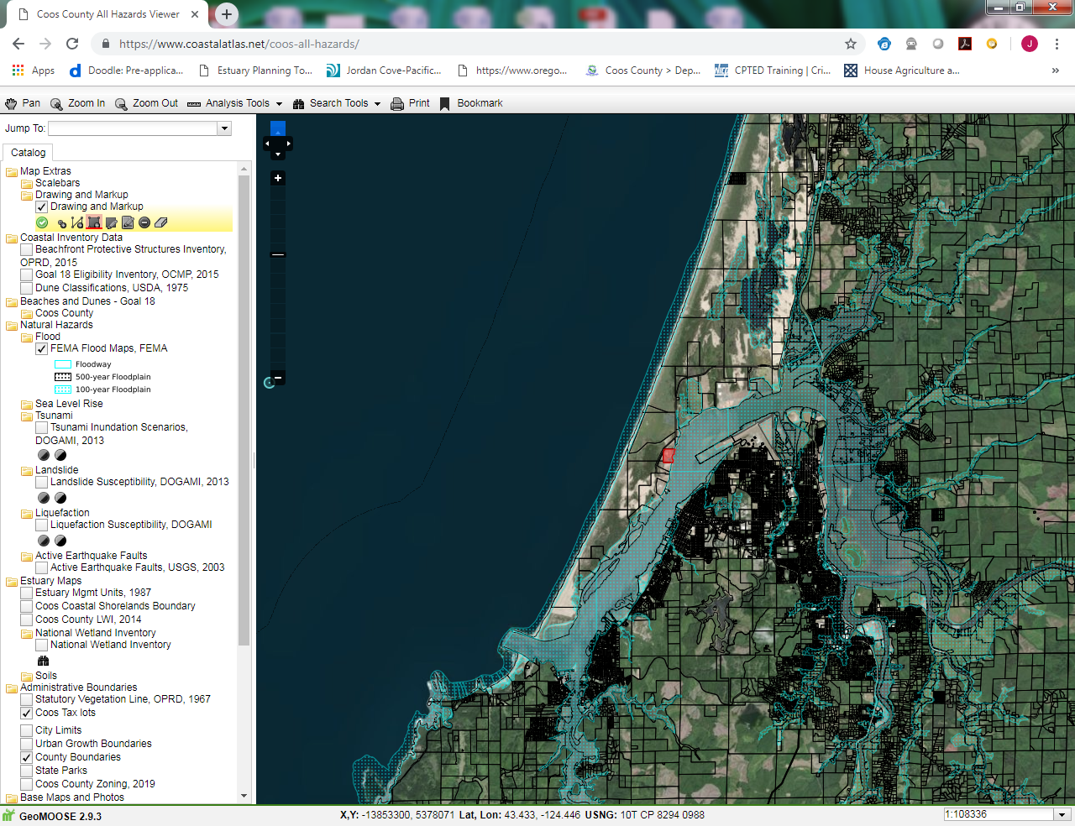

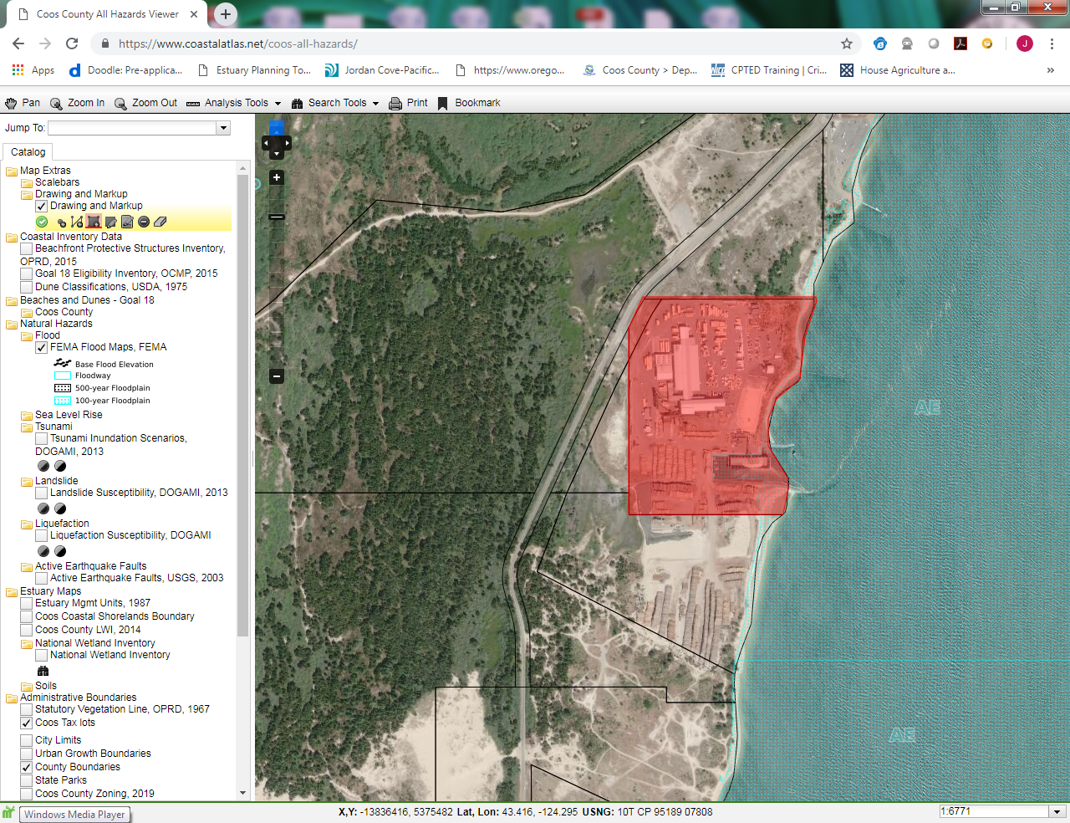

Zone Map

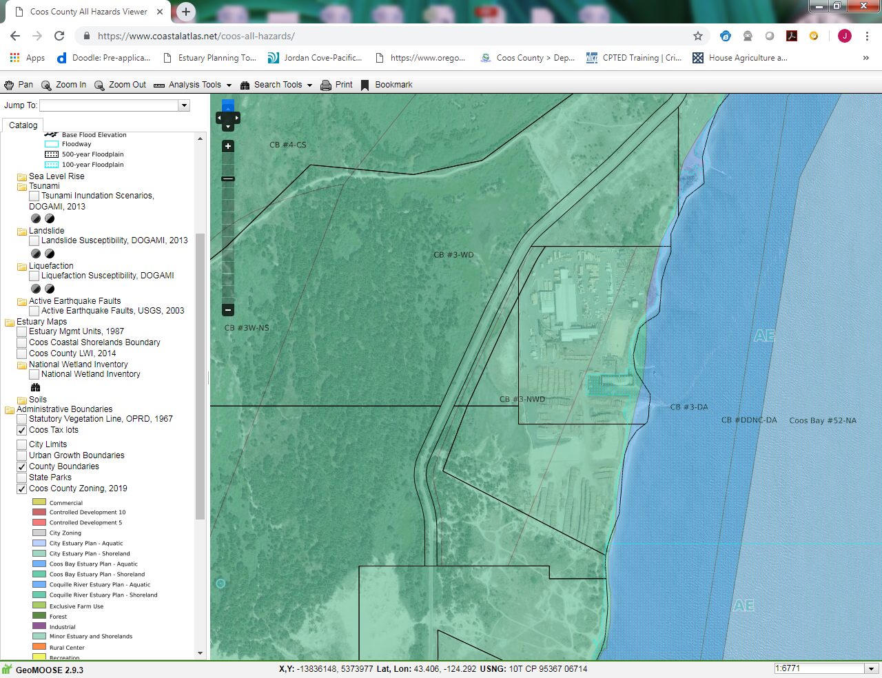

**EXHIBIT "B"**

**Staff Report**

### SECTION 5.10.300 REVIEW FOR Uses and actives in an estuary management plan zonE:

1. Compliance determinations will be reviewed for any permitted uses not subject to general conditions which require polices to be addressed. If the policies require a conditional use that process shall be followed.
2. If it is determined that other land use reviews are required the planning, staff will provide a letter explaining what applications and criteria are required to the applicant and the application will be deemed incomplete until all submittal requirements have been met. Once all conditional use applications have received a final land use decision a zoning compliance letter will be issued.
3. If a compliance determination application is received for a use or activity that is not listed a denial will be issued unless § 4.1.190 Uses Not Listed applies.
4. If no other reviews are required and discretion was used to determine compliance the compliance determination decision will serve as the final land use decision. However, if the application simply requires a check-off of clear and objective development standards, no administrative conditional use review was required a zoning compliance letter will be issued and the compliance determination will not be characterized as a land use decision.

All new and replacement developments, with the exception of sewage disposal system permits, require a driveway permit and/or parking permit prior as part of this review unless one has been completed. Industrial and Commercial development will require a parking plan to be submitted as part of the compliance determination review. Parking plans will be reviewed by the County Roadmaster.

### SECTION 5.10.400 NOTIFICATION:

If the property is located within in an area that requires a notification to other agencies for comments that notification shall be mailed out for comments once the review of the Compliance Determination begins. Staff will review special development consideration maps and overlay maps to determine if a notice is required.

If the property is located in an area that requires one of the following notifications, the final land use decision will not be issued until the comment period has expired.

* Oregon Department of Fish and Wildlife has 10 days to comment.
* Local Tribes have 30 days to comment.
* Department of State Lands (DSL) has 30 days to comment.
* Oregon Department of Aviation has 30 days to comment, unless notice has been submitted to FAA for comment.
* Review the files to see if a driveway confirmation has been completed by the Road Department.
  + Driveway confirmations are required for replacement and new dwellings. Driveways may be bonded to allow for all development to be completed.
  + If the development is commercial or industrial a parking plan will be required to be reviewed by the Roadmaster for compliance with parking standards.

If the Compliance Determination is to serve as a final land use decision then there will be a notice of the decision mailed to the applicant and to all neighborhood or community organizations recognized by the County and whose boundaries include the site and to the owners of record of property on the most recent property tax assessment roll where such property is located:

1. Within 100 feet of the exterior boundaries of the contiguous property ownership which is the subject of the notice if the subject property is wholly or in part within an urban growth boundary;
2. Within 250 feet of the exterior boundaries of the contiguous property ownership which is the subject of the notice if the subject property is outside an urban growth boundary and not within a farm or forest zone;
3. Within 750 feet of the exterior boundaries of the contiguous property ownership which is the subject of the notice if the subject property is within a farm or forest zone.

If appealed the process in Article 5.8 will be followed. If a use is permitted outright the use may not be the subject of appeal unless discretion was used to determine if a standards or policies have been met then the decision may be appealed. Compliance determinations are only valid for a two year period. However, a two year extensions may be provided so long as the project has not changed which would requiring additional review.

## SECTION 3.1.450 Supplemental provisions that apply to all zoning listed in Article 3. ***

1. Accessory Structures are customarily accessory to a lawfully established principle use shall be allowed as set forth below:
   1. An accessory structure may be located on the same lot, parcel or tract under the same ownership as the lot, parcel or tract that contains the principle use.
   2. Any attached or detached accessory structure shall maintain the same setbacks established by the zoning district for the principle use.[OR 91-05-006PL 7/10/91]

**FINDING: The subject property is located on the North Spit with access from Trans-Pacific Lane. The subject property is described as Tax Lot 200 of Township 25, Range 13, Section 07 on the Coos County Assessment Map. The property was lawfully created and reconfigured through a property line adjustment completed in 2009. The property was approved for the construction of a Industrial and Port Facility in 1984. Since that time a portion of the property has been rezoned and a lumber facility has been lawfully established. The property has been granted several permits in conjunction with the expansion of the facility. This is accessory structure located on the same unit of land that is detached to house additional lumber milling equipment. The primary use has been established and all notices were provided.**

**Staff finds this did not require the use of discretion; therefore, a notice of decision is not necessary. and the additional fee will be refunded.**

**A sign-off from the road department is required to ensure the increase use of the site will not warrant additional parking.**

**Due to the fact that in the past the Confederated Tribes of the Coos, Lower Umpqua & Siuslaw Indians have made comments concerning the area and requested to be contacted prior to any ground disturbance staff is going to condition this approval that contact be made. Staff has also included an inadvertent discover plan for cultural resources to ensure the applicant understands who to contact.**

**Due to the fact the property is within the Airport Overlay staff has reviewed the development and comments from Oregon Department of Aviation require that this structure cannot exceed the height of the other structures on this property.**

**Once the driveway confirmation or has been received the applicant may obtain a zoning compliance letter.**

**Inadvertent Discovery Plan for Cultural Resources**

Southport Lumber File #ACU-19-050

Southport Lumber proposes to build an accessory structure to increase the current mill site. This plan is required to follow as the proposed work is in the vicinity of a known archaeological site.

**The Inadvertent Discovery Plan (IDP) should be followed if cultural materials including human remains are encountered during construction.**

**Protocol for coordination in the event of inadvertent discovery:**

• In the event of an inadvertent discovery of possible cultural materials, including human remains, all work

will stop immediately in the vicinity of the find. A 30 meter buffer should be placed around the discovery with work being able to proceed outside of this buffered area unless additional cultural materials are encountered.

• The area will be secured and protected.

• The project manager/land manager will be notified. The project/land manager will notify the State Historic

Preservation Office (SHPO). If possible human remains are encountered, the Oregon State Police, Commission on Indian Services (CIS), SHPO, and appropriate Tribes will also be notified.

Oregon State Police: Chris Allori 503-731-4717

CIS: Karen Quigley 503- 986-1067

Appropriate Tribes: Confederated Tribes of the Coos, Lower Umpqua & Siuslaw Indians 541-888-7513

SHPO: Dennis Griffin 503-986-0674, John Pouley 503-986-0675, or Matt Diederich 503-986-0577.

• No work may resume until consultation with the SHPO has occurred and a professional archaeologist is able

to assess the discovery.

• If human remains are encountered, do not disturb them in any way. *Do not call 911*. Do not speak with the

media. Secure the location. Do not take Photos. The location should be secured and work will not resume in the area of discovery until all parties involved agree upon a course of action.

• A professional archaeologist may be needed to assess the discovery and they will consult with SHPO and

appropriate Tribal Governments to determine an appropriate course of action.

• Archaeological excavations may be required. This is handled on a case by case basis by the professional

archaeologist and project manager, in consultation with SHPO and appropriate Tribes.

**When to stop work:**

Construction work may uncover previously unidentified Native American or Euro-American artifacts. This may occur for a variety of reasons, but may be associated with deeply buried cultural material, access restrictions during project development, or if the area contains impervious surfaces throughout most of the project area which would have prevented standard archaeological site discovery methods.

Work must stop when the following types of artifacts and/or features are encountered:

***Native American artifacts may include (but are not limited to):***

• Flaked stone tools (arrowheads, knives scrapers etc.);

• Waste flakes that resulted from the construction of flaked stone tools;

• Ground stone tools like mortars and pestles;

• Layers (strata) of discolored earth resulting from fire hearths. May be black, red or mottled brown and often

contain discolored cracked rocks or dark soil with broken shell;

• Human remains;

• Structural remains- wooden beams, post holes, fish weirs.

***Euro-American artifacts may include (but are not limited to):***

• Glass (from bottles, vessels, windows etc.);

• Ceramic (from dinnerware, vessels etc.);

• Metal (nails, drink/food cans, tobacco tins, industrial parts etc.);

• Building materials (bricks, shingles etc.);

• Building remains (foundations, architectural components etc.);

• Old Wooden Posts, pilings, or planks (these may be encountered above or below water);

• Remains of ships or sea-going vessels, marine hardware etc.;

•Old farm equipment may indicate historic resources in the area.

• Even what looks to be old garbage could very well be an important archaeological resource;

***When in doubt, call it in!***

**Proceeding with Construction**

• Construction can proceed only after the proper archaeological inspections have occurred and

environmental clearances are obtained. This requires close coordination with SHPO and the Tribes.

• After an inadvertent discovery, some areas may be specified for close monitoring or ‘no work zones.’

Any such areas will be identified by the professional archaeologist to the Project Manager, and appropriate Contractor personnel.

• In coordination with the SHPO, the Project Manager will verify these identified areas and be sure that the

areas are clearly demarcated in the field, as needed.